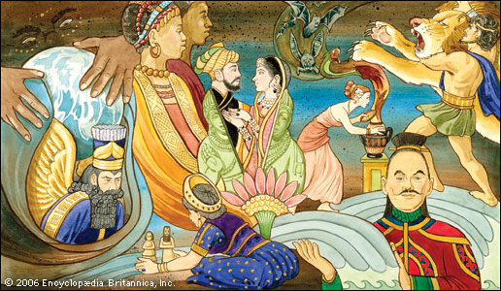
Myths from Around the World Project
Name: _________________
Due:

Step 1- You will be assigned a culture and myth relating to that culture. Read about your myth and the country it was from. Fill out the Setting, Problem, Hero, Ending chart to track your learning.

Step 2- Visit www.mythencyclopedia.com and research your mythological character. Fill out the double entry journal from the information presented on the website.

Step 3- Research the country of origins for your myth and identify the 5 themes of geography.

Step 4- Present your finding to the class. Be prepared to share your myth and give a summary of the myth. Also share information about the country/culture the myth came from and what the myth tells about the culture.
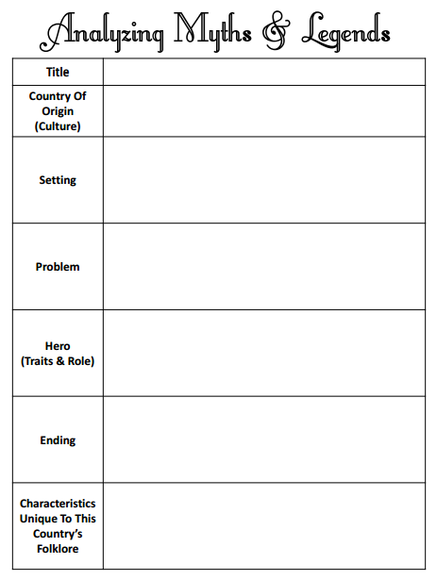

Presentation
- Name of Country/Region____________________________________________

- Give description of that country- (Use the 5 themes as a guide )
________________________________________________________________________________________________________________________________________________________________________________________________________________________________________________________________________________________________________________________________________________________________________________________________________________________________________________________________
- Name of Myth_____________________________________________________

- Summary of Myth (Remember SWBST model) ________________________________________________________________________________________________________________________________________________________________________________________________________________________________________________________________________________________________________________________________________________________________________________________________________________________________________________________________________________________________________________________________

- What does that myth teach you about the culture? ________________________________________________________________________________________________________________________________________________________________________________________________________________________________________________________________________________________________________________________________________________________________________________________________

Myths from Around the World Project Rubric
Name: ____________________________
Due Date:
 | 10 Pts | 8 Pts | 6Pts | 4 Pts
Requirements | Student meets all requirements as outlined on the project sheet. | Student meets most of the requirements as outlined on the project sheet. (1 not included) | Student is missing some of the requirements as outlined on the project sheet.  (less than 1/2 not included) | Student is missing most of the requirements as outlined on the project sheet. (1/2-3/4 not included)
Time and Effort | Much time and effort went into the planning and design of the project. It is clear the student worked diligently to complete this project to the best of his/her ability. | Student could have put in more time and effort in order to complete this project to the best of his/her ability. | Time not used wisely. Minimal effort is shown. | Student put in little or no effort.
Understanding | Student demonstrates understanding of the myth/country through a deep analysis of the given work. | Student demonstrates some knowledge of the myth/country. | Student demonstrates little knowledge of the myth/country . | Student does not demonstrate a clear understanding of the myth/novel.

Total Pts ________________________

Africa
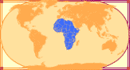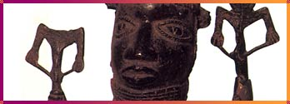
Hare looked out over his field. If he was going to have food to eat, he would have to plant a crop. But if he was going to plant a crop, he'd have to clear the field first. That was a lot of work — more work than Hare wanted to do.
Hare was a clever animal, so he soon had an idea. He dragged a length of rope behind him and lay in wait in the bushes outside his field. A big African elephant came lumbering along. Hare bet the elephant he could beat him in a tug-of-war. The large elephant laughed at the idea, coming as it did from such a small animal. He scooped up the rope with his trunk. Hare picked up the other end and scampered through the bushes and across his field. There he hid behind another row of bushes.
Soon enough a muddy hippopotamus waddled by. Hare dared the hippo to beat him in a tug-of-war. The proud hippo picked up the rope with his teeth. Hare hopped into the bushes and gave the rope a tug. When the elephant and the hippo felt the rope move, they each pulled hard. The powerful animals dragged the rope, back and forth, back and forth, until night fell. Each time the rope moved, it plowed another row in clever Hare's field.
Africa did not develop one overall myth system because Africa itself does not have one people, one history. Its different peoples speak more than 1,000 languages and its mythologies are just as vast and varied. African myths, legends, and tribal histories were shared through ritual storytelling, proverbs, chanted poems, or songs. Stories about wily animal tricksters like Hare or Anansi the Spider, are particularly popular.
http://teacher.scholastic.com/writewit/mff/myths.htm

Central America
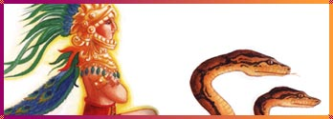
Quetzalcoatl was striking to look at. He was tall and fair-skinned. His eyes were deep and his voice carried over many miles. He was the beloved, plumed serpent god, the god who had brought people learning, laws, and the ancient calendar, by which all might be revealed or ordained.
Quetzalcoatl was the spirit of love, the force of life. He was sickened by lives cut short in his honor. He rejected human sacrifice, and angered his eternal enemy Tezcatlipoca. This bloodthirsty god showed the benevolent god his magic smoking mirror. Quetzalcoatl was shocked to see his old, sagging face. Tezcatlipoca dressed Quetzalcoatl up in a bright, plumed robe and mask. The evil god then tricked the good god into getting so drunk that he slept with his own sister.
When Quetzalcoatl awoke, he was filled with remorse. He lay in a stone box for four days as penance. The god felt so unworthy, that he ordered his followers to burn his palace and abandon the city. Then Quetzalcoatl lit his own funeral pyre and leaped in. Beautiful birds flew out of his ashes. Though some say the god world bedecked himself in his feathered serpent robe and royal mask and sailed off on a raft of serpents. They await his return.
Olmecs, Maya, Aztecs, and other ancient peoples of Mexico and Central America had complex mythologies that involved world destruction and rebirth. Many of their gods and goddesses had dual natures. These divinities could have male and female aspects. Even a protective, loving god like Quetzalcoatl, had a dark, violent opposite form.
http://teacher.scholastic.com/writewit/mff/myths.htm

Celtic Lands
Cuchulainn was ready for battle. His hair bristled and stood on end. One eye sunk into his head and the other became a big red, bulging orb. His foaming mouth spread from ear to ear and a column of blood shot out of his head. "The Hound of Culann" was ready to lead his Ulster men against the invasion by his bitterest enemy, Queen Medb. Unfortunately, Cuchulainn would have to advance alone — the Queen immobilized his army with a curse.
The mighty Irish warrior took up arms anyway. Single-handed, he tore through Medb's ranks, leaving broken bodies on either side of him. The queen was frantic. Cuchulainn must be defeated. She joined forces with Morrigan, goddess of war, whose love Cuchulainn had rashly spurned, and three sorcerer daughters of a warrior he had killed. Their magic and betrayal brought a madness upon the Celtic hero. He was mortally wounded with his own spear.
Bloody, pierced by spears, bruised by blows, Cuchulainn refused to fall in his final battle. He lashed himself to a stone pillar and died on his feet. Still, his enemies didn't dare approach his body, until three days later Morrigan flew down as a crow and settled on the corpse's shoulder.
The Celts were not a nation, but a combination of peoples who spoke related languages. Ancient Celtic tribes migrated as far east as Asia Minor and as far west as Ireland. A good Celtic myth, like that of Cuchulainn, always involved fighting, honor, love, or a quest, complicated further by oaths and obligation or magic and enchantment.
http://teacher.scholastic.com/writewit/mff/myths.htm

China
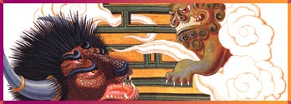
Huang Di, the ancient Yellow Emperor, stood bravely at the head of his army of gods, bears, tigers, and leopards. At the other end of the battlefield loomed the oxen-horned giant Chi You, backed by his army of demons.
Huang Di came to defend his imperial throne; Chi You came to demand it.
Chi You sneezed loudly and a thick, white fog covered the battlefield. No one could see a thing. Huang Di's army lashed out blindly until his quick-witted minister created a compass. Huang Di gathered the survivors and escaped.
Chi You was furious. The angry giant called in demon forces to help him. The winds blew wildly. The sky blackened and a fierce driving rain fell all over the battlefield. The Emperor's army was drowning.
Huang Di called for his most powerful weapon — his daughter Ba.
Ba strode through the flood. A terrific heat spread from her body and dried up the waters. Huang Di then fashioned a drum out of a sea monster's hide. When he crashed down his huge, powerful drumsticks, a terrible thunder shook the mountains. Chi You's army was paralyzed with fear. The Emperor's army rushed forward... to victory!
China has the oldest existing civilization in the world. Its earliest myths date from more than 4,000 years ago, but its mythologies were ever-changing. Names, ranks, and the importance of Chinese deities were closely connected to the ruling powers of a region or an era. Much of China's early history is intertwined with its mythic history. The line between mythic leaders, like Huang Di, and historic figures is often very blurry. Ancient Chinese mythology was later transformed by the spread of the Taoist, Confucian, and Buddhist religions.
http://teacher.scholastic.com/writewit/mff/myths.htm

Egypt
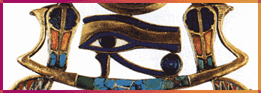
A voice from the heavens sang out the joyful news: Osiris, the lord of all things, had been born.
The fortunate baby grew to be a handsome, wise king. He taught his unruly people to lead a more civilized life. He showed the Egyptians how to sow and reap crops. He instructed them in laws and had them build temples to the gods. He invented the flute so that the Egyptians might bring music to their worship. Osiris was beloved by all — except for his jealous brother Seth.
Seth secretly took Osiris's measurements and had a magnificent chest built, exactly the size of the king. At a banquet, he playfully suggested that anyone who fit in the chest could keep it. Osiris climbed in. Seth quickly slammed the lid down, nailed it shut, and threw it into the sea.
Osiris's grieving widow Isis wailed at the treachery. She chopped off her hair and tore off her clothes. Then Isis wandered all the way to Phoenicia to find her husband's body, which she brought back and hid in a Nile swamp.
One night Seth tramped through the swamp while hunting. He spied the chest, threw it open and chopped Osiris in 14 pieces. Then he scattered the body parts. Isis began the painful journey to retrieve the pieces. She knew her beloved husband could not make his own journey to the underworld if he was not whole.
When Isis had completed her sad task, she and the gods Thoth and Anubis embalmed and mummified Osiris. They created the first funeral rites. Isis changed herself into a bird and breathed life into her husband by flapping her wings. Osiris was reborn, but claimed another throne: he became ruler in the land of the dead.
Floods, droughts, the burning desert sun: nature was extreme in ancient Egypt. There was no escaping the forces of the natural world, or the universal opposites, life and death. Egypt's complex mythology reflected this. And the most profound aspect of Egyptian life was its cult of death. Egyptians prepared for an afterlife that would be similar to their present life. Osiris, king of the dead, god of death and rebirth, ruled over their underworld.
http://teacher.scholastic.com/writewit/mff/myths.htm

Greece
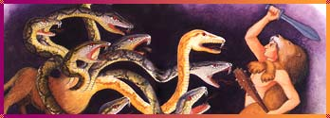
The baby Heracles lay fast asleep. Two serpents slithered around his crib and reared their ugly heads. Before they could strike, Heracles woke up, grabbed the giant snakes and strangled them.
The hero of Greece had just performed his first famous feat.
Heracles was the son of the great god Zeus and a mortal woman. This made him a powerful enemy: Zeus's wife Hera. It was she who had sent in the serpents. When Heracles grew into manhood, the jealous queen smote him with a frenzy of madness. The hero committed the unthinkable crime: he killed his wife and children.
To atone for his heinous deed, Heracles was condemned to perform 12 deadly labors. Any one of these tasks would have felled the mightiest of heroes. Heracles did not flinch. He quickly sought out his first challenge and wrestled a ferocious lion to death.
Heracles draped his eight-foot body in the lion's skin; he wore the wild beast's head as his hood. Then he waded through the swamp to find his next foe: the dreaded Hydra.
This hideous monster had the body of a wild dog and nine serpent heads. Its mere breath alone was poisonous — and fatal. Heracles, armed with club and sword attacked. But each time he chopped off one of the Hydra's heads, two more fanged ones grew back. The battle raged, the hissing grew louder, the air was filled with the Hydra's venom. Finally, Heracles bested the monster. Each time Heracles lopped off a head, his servant seared shut the neck with a burning branch.
The peoples of many ancient civilizations bowed down to a remote or almighty god-king, whose rule they never questioned. The Greeks put human beings in this powerful position. Many Greek myths were about extraordinary, but mortal heroes (or half-mortal, like Heracles) from a past era. In their divine myths, the Greeks made their gods and goddesses immortal, endowed them with remarkable powers — and gave them very human personalities!
http://teacher.scholastic.com/writewit/mff/myths.htm

India
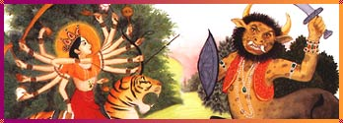
Mahisha, the fierce buffalo demon, was on a terrible mission: to conquer the world and rout the gods. He gored and slashed his way through battle after battle. The gods retired; the monster ruled — until a stupendous sound shook the earth.
Durga spoke!
The great goddess had sprung forth full-grown, created by the energy of the gods, who knew Mahisha could only be killed by a woman. Durga roared her challenge to Mahisha; the buffalo demon was enraged!
The red-robed goddess charged into battle on her magnificent lion. Her 18 arms whirled furiously overhead, each one brandishing some weapon of the gods: a thunderbolt, a trident, a bow and arrow, a rope of snakes. The buffalo demon quickly changed shapes. He became a lion, a warrior, an elephant; Durga slew each of his demon forms. Mahisha was no match for the mighty goddess. She was beautiful, invincible, fearless. Mahisha was forced to assume his monstrous buffalo shape again. He hurled mountains at the goddess. Durga dodged his attack — and then leaped up and cut off the buffalo demon's head!
Most of India's myths, like the story of Durga, are part of Hinduism, one of the world's oldest religions. Hindu beliefs and myths are driven by two very powerful forces: creation and destruction. Everything in the cosmos, even gods and goddesses, spirals through an everlasting cycle of birth, death or dissolution, and reincarnation.
http://teacher.scholastic.com/writewit/mff/myths.htm

Japan
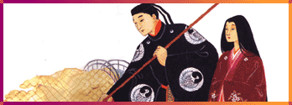
Izanagi and Izanami glided down the rainbow-striped Floating Bridge of Heaven. They stared into the oily, primeval ocean of chaos below. Izanagi dipped his jeweled spear and stirred the swirling jellyfish-like mass; a glistening droplet fell from his spear point and turned into an island.
Izanagi and Izanami descended to the island they created and built a tall, sacred column. Izanagi circled the column in one direction, Izanami went in the other. When they met face to face, they married. Izanami then gave birth to the eight islands of Japan, the mountains, the seasons, the gods of land and water and all the forms of nature. After giving birth to the fire god, Izanami died of a burning fever.
Izanagi was so crazed with grief that he chased after his wife into the dark Underworld. He pulled a comb from his hair and lit it, just to get a glimpse of his beautiful beloved.
He sprang back in horror! Izanami had become a rotting corpse. She shrieked in rage at being seen. Izanagi fled; his hideous wife and her horde of demons and devils were at his heels. He just barely reached the mouth of the Underworld and rolled a boulder into it. Izanami wailed that she would kill 1,000 people a day in revenge. Izanagi vowed that 1,500 people would be born each day. As they had married from either side of the column, Izanagi and Izanami divorced from either side of the boulder. The living and the dead were separated forever.
Like the rising sun on its flag, Japan's mythology celebrates two important concepts: nature and nation. Japanese myths, like the story of Izanagi and Izanami, explain the origins of its islands and the divine line of its emperors. They honor the nature spirits of an agricultural community and the warriors and gods of an imperial culture.
http://teacher.scholastic.com/writewit/mff/myths.htm

Norse Lands
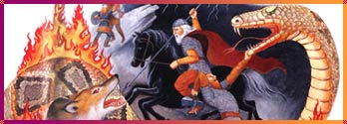
An earthquake shatters Fenrir's invincible chains. The great wolf swallows the sun, and winter covers the earth for three long, cold years.
Then a mighty blast from the horn of Hemidall, guardian of the gods' home, echoes across the world. The golden cock atop the World Tree crows loudly in reply. These are the signs. Ragnarok, "The Twilight of the Gods," the ultimate battle, the end of the world has arrived.
When Ragnarok comes, gods and giants will clash. The world serpent will rear up, spew out poisonous fumes and cause a tidal wave. Thor, the thunder-god, the champion of the gods, will raise his mighty hammer and strike the serpent dead — but then fall dead himself from the creature's fatal venom. Odin, the god of death, the most powerful of all the gods, will mount his eight-legged steed and charge against Fenrir — but the wolf will devour him. Odin's son will tear open the jaws of the vicious wolf and shove a sword down to his very heart.
One by one the gods will fall in unspeakable battles. The world will be engulfed in cataclysmic flames. Even the stars will fall. Ragnarok: when everything will be lost in a fiery blaze.
The Vikings lived in a world that was harsh and dangerous. Their mythical world was just as threatening. Sky gods fought earth gods. Giants were always lurking. The violent end of the world was inevitable. Even Odin and Thor, the most powerful gods, were doomed to destruction at Ragnorak, the final, violent battle.
http://teacher.scholastic.com/writewit/mff/myths.htm

North America
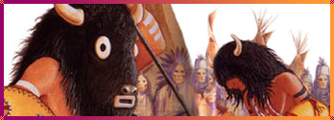
When the buffalo had disappeared and hunger was upon the land, White Buffalo Calf Woman was sent down to the Lakota people.
She appeared to two young Lakota warriors. Her white hide-skin dress glowed; her feet hovered above the ground. One warrior recognized her beauty and power; the other reached out to touch her roughly. He disappeared in a cloud — and reappeared as nothing but a pile of bones.
The remaining warrior rushed to his people. They prepared for the coming of White Buffalo Calf Woman by building a special tipi. She arrived carrying sacred herbs and a tightly wrapped bundle. Inside was the most sacred peace pipe. White Buffalo Calf Woman taught the Lakota the peace prayers and the pipe ceremony. Then she bade them follow her.
White Buffalo Calf Woman walked eastward. The Lakota trailed behind her and watched in amazement as the beautiful woman turned back into a white buffalo. She rolled over four times, becoming a red, black, brown, and finally a white buffalo again. Then she disappeared over the horizon.
And just as suddenly a great herd of buffalo appeared.
To Native Americans, the supernatural world has a tremendous impact on the natural world. There is a spirit quality to all things in the natural world. Contact with these spirits, through ceremonies such as the peace pipe ritual or the buffalo dance, is not only desirable, it is essential for the well-being of the community and for a deeper understanding of the world.
http://teacher.scholastic.com/writewit/mff/myths.htm

Oceania & Australia
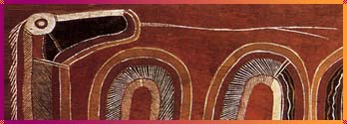
Maui of a Thousand Tricks was an ugly, excitable, but quick-witted half-divine, half-mortal trickster who was covered in tattoos. If he didn't like the ways things were, he changed them. And there were many things Maui didn't like. For example, the sun.
Every day, Maui watched human beings scramble to work, or plant, or cook, or make bark cloth in the few precious hours between sunrise and sunset. There was never enough time, the sun moved too fast, the people suffered. They had no choice but to eat their food raw.
Maui grabbed his rope and his grandmother's magic jawbone. With a quick flick of the rope, he lassoed the sun and beat the sun-god with the jawbone, until the golden one agreed to move more slowly across the sky. Then Maui looked closely at the sky itself. It hung way too low. With a mighty heave, Maui shoved the firmament up higher.
The Maui went fishing.
His brother wouldn't share their bait, so Maui punched his own nose and used his blood to fish. He hauled in catches so big they became the Polynesian islands.
The mythologies of Oceania and Australia tell of long, symbolic journeys, creation but no beginning, time that is timeless, gods, heroes like Maui, even animals whose actions shaped the world. All these myths and their fascinating variations were shared orally by kin, clan, or island group because the people of the Pacific did not originally have writing.
http://teacher.scholastic.com/writewit/mff/myths.htm

Rome
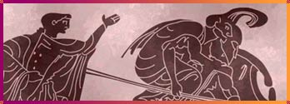
Aeneas tightly clasped a golden tree bough in his hand. It would give him safe passage on his terrible journey — to the underworld to seek out his father, Anchises.
The Trojan hero followed his guide, the wise woman, the Sibyl of Cumae, deep into the dark forbidding cave that led to the land of the dead. They traveled the road of lost spirits, shadows adrift, and frightening horrors of disease, death, and discord until they reached two rivers. Charon, the ferryman of the dead and buried, reluctantly rowed them across while Cerebus, the three-headed dog of hell, furiously barked at these visitors from the world of the living.
Aeneas kept going. He passed through places of sorrow and punishment until finally he reached his destination: the Elysian Fields, the beautiful eternal home of those who had lived a good life. His father was waiting. Anchises embraced his son. Then he showed him a wondrous vision: the future! Aeneas looked in awe at his own descendants to come. He saw that they would do great deeds and become a great people, the Romans. Aeneas was dazzled by the revelation. He held his father close one more time, then returned to the land of the living — and set sail for Italy.
The Romans renamed the Greek gods and goddesses, and redirected their myths. Greek myths could overlap, interlock, or even contradict each other. They served many purposes. Roman myths were for the sake of Rome. They were used to re-create the city's history, for example, its descent from Aeneas, to explain Roman society and to reinforce its rules, rites, and customs.
http://teacher.scholastic.com/writewit/mff/myths.htm

South America
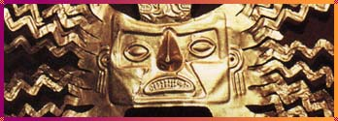
In ancient time, Jaguar, the Master of Fire, ate his meat cooked, while people ate their meat raw. People scrambled to catch the animals that were their food. Jaguar, the great hunter, had bows and arrows.
Jaguar, with his flared nostrils and pointed teeth, was a powerful being. But he took pity on a poor hungry man he met in the jungle. He took the man back to his home, where a warm fire burned. The grilled meat had a delicious smell, so new to the man. He ate hungrily. Jaguar was generous with his weapons, too. He taught the man to hunt with bows and arrows. The man repaid Jaguar by killing his wife and stealing his fire.
Since then, the people have feared Jaguar's wrath. And the ferocious feline has lived alone in the jungle, wary of civilization, waiting for revenge.
Many of the ancient cultures throughout the South American Continent held some kind of belief in the supernatural power of jaguars or anacondas. They also worshipped not only the sun, but the moon, the stars, and a whole host of nature deities. Sun gods were particularly important; the Incas even called themselves the children of the sun.
http://teacher.scholastic.com/writewit/mff/myths.htm

Southeast Asia
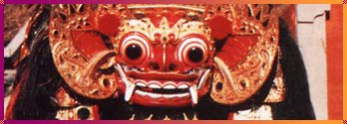
Dragon blood flowed through Lac Long Quan's veins. The heroic warrior king feared nothing and no one. He boldly challenged sea monsters; he bravely battled tree monsters; he let no wild beast rampage through his beloved Vietnam. All his grateful countryman had to do was call "Father!" and Lac Long Quan would appear to save them.
One sight alone stopped Lac Long Quan. That was the incredible beauty of Au Co, an immortal mountain fairy spirit. The dragon lord was bedazzled. He married Au Co and shortly after she produced a large sack of eggs. The sack grew larger and larger. On the seventh day, it was so enormous it burst and 100 sons were born to the dragon lord and his fairy wife.
At first, the royal family lived in harmony. But King Lac Long Quan was a dragon, so he needed to live by water. And Queen Au Co missed her ancestral mountain home. Lac Long Quan took 50 of their sons and moved to the lowlands. He taught them to fish, wearing tattoos to scare off sea monsters, to sow rice and to cook it in slender bamboo shoots. Au Co took their other 50 sons and moved up to the highlands. She taught them to raise animals, to grow fruit trees, and to build homes out of sturdy bamboo stilts.
Lac Long Quan and Au Co lived separately ever after, but together they watched over their beloved country.
Many of the countries in Southeast Asia trace their origins to a mythic founder, who may be a dragon, like Vietnam's Lac Long Quan, or a hero or a princess married to a dragon. These cultural ancestors were to be honored. Often they were the ones who had shown a people an essential skill like rice planting, cooking, or weaving.
http://teacher.scholastic.com/writewit/mff/myths.htm

The Near East
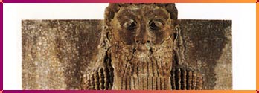
The people of Uruk were irritated by the wild behavior of Gilgamesh, their powerful king who was one-third mortal, two-thirds divine. The gods answered the people's prayers and sent down Enkidu, a brawny, shaggy-haired champion to rein in Gilgamesh.
The wild man and the willful king met. They wrestled together, locked in furious embrace. Gilgamesh barely bested his opponent. Enkidu bowed before a strength greater than his own. The two became inseparable friends and fellow adventurers.
They traveled to a great cedar forest for a tree-cutting contest. But first they had to slay the fire-breathing giant of the forest, Humbab. So fearful was this demon giant, that even Gilgamesh quaked before him. But Humbab had neglected to don his usual seven coats of armor. He was vulnerable — and soon headless.
Gilgamesh's bravery caught the attention of the goddess Ishtar. She was smitten by the handsome king. He ignored her and ignited her wrath. Ishtar sent down the savage bull of heaven. Every time the bull snorted, its breath carved deep ravines through the earth. The monster ravaged Gilgamesh's kingdom. The heroes went after it.
Enkidu seized the bull's tail and Gilgamesh slew it. Enkidu tore off one of the bull's legs and threw it at Ishtar. The goddess demanded he be punished. Enkidu then bore the gods' wrath and died, too.
Civilization started here — and with it came influential gods, goddesses, heroes, demons, and mythical beasts. The ancient Near East produced deities later found in Greco-Roman mythology. Epic myths, such as the story of Gilgamesh, were read at ritual festivals to celebrate the triumph of good over evil. The struggle between the two was an important part of Near Eastern myth.
http://teacher.scholastic.com/writewit/mff/myths.htm

